Use Case Diagram:

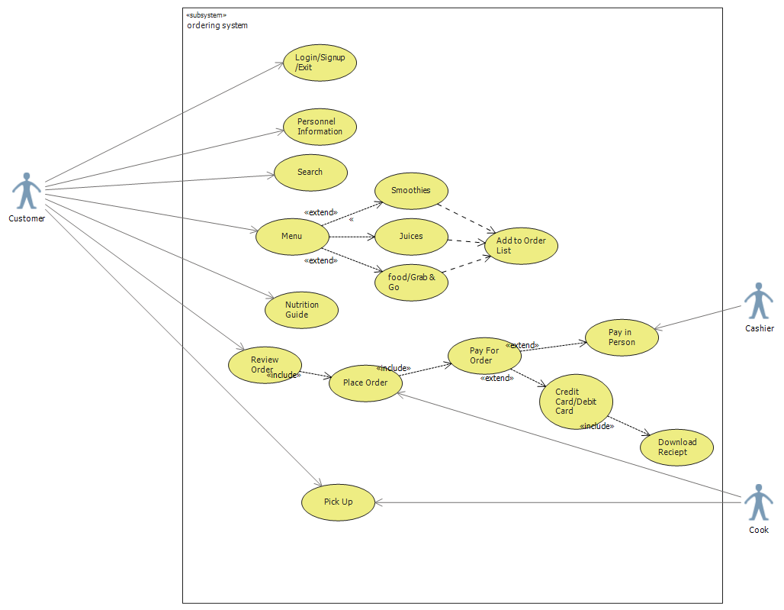

Use Case Description:

|  |
| --- |
| Use Case Title: Ordering System |
| Primary Actor: Customer, Cashier, Cook |
| Level: Sea Level |
| Stakeholders: Customer |
| Precondition: User downloads the app and must be online with web access |
| Minimal Guarantee: Rollback of any uncompleted transactions |
| Success Guarantee: Files desired by customer load correctly and all information is updated |
| Trigger: Customer access the homepage |
| Main Success Scenario:  1.Customers logs in or signup.  2.Customers browse through the menu – Smoothies, Juices and food.  3.Customer adds item to wishlist.  4.Customer review and place their order and select the payment mode.  5.Customer review their personnel information like phone number.  6.Cook gets the order and gets it prepared.  7.Customer shows receipt and pick their order. |
| Extensions:  1.Customer gets page not found.  Rollback to previous activity.  2.Customer wants to change or cancel their order.  Can do within specified time.  3.Payment is interrupted.  Customer went back to previous page. |